Midpoint

Definition
# Source: AI Source: Provided by: [Data Path: Persons Table -> ID Column: 1, Name_En Column: Motasem Essam] -> From: [ChatGPT] on [7/25/2026]
A midpoint is the point that divides a line segment into two congruent (equal-length) segments.
If $M$is the midpoint of $\overset{‾}{AB}$, then:
$$\boxed{AM=MB}$$
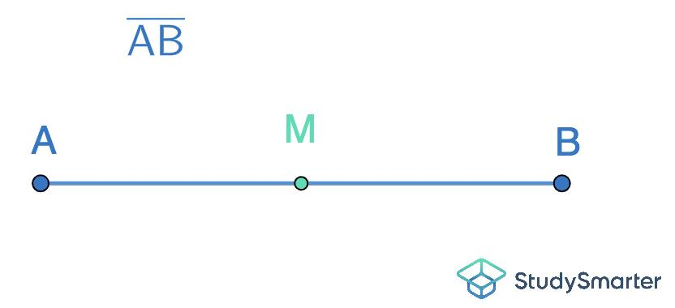
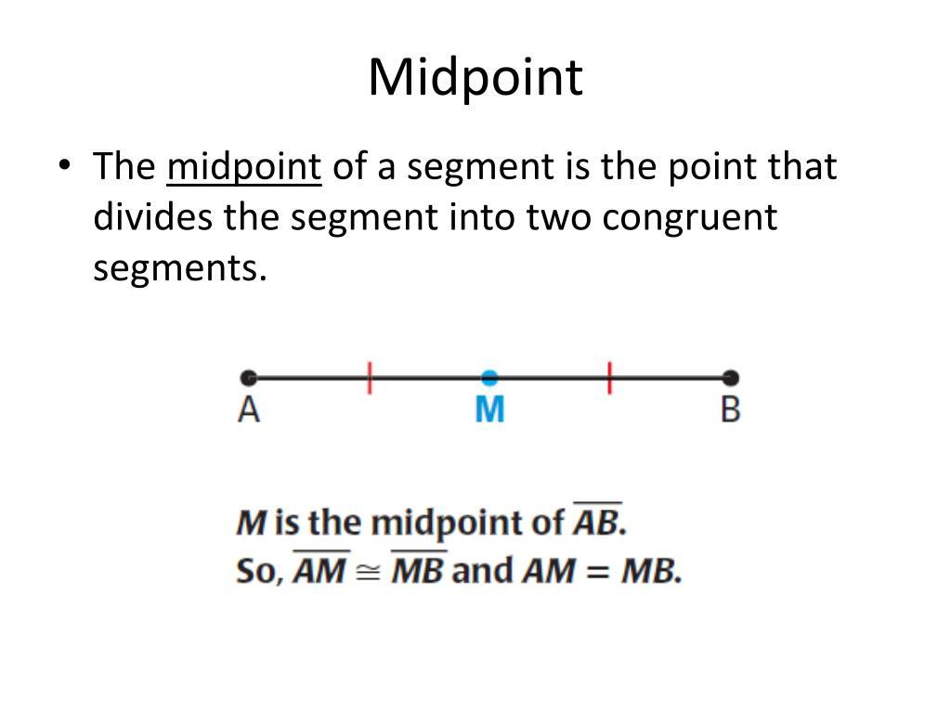
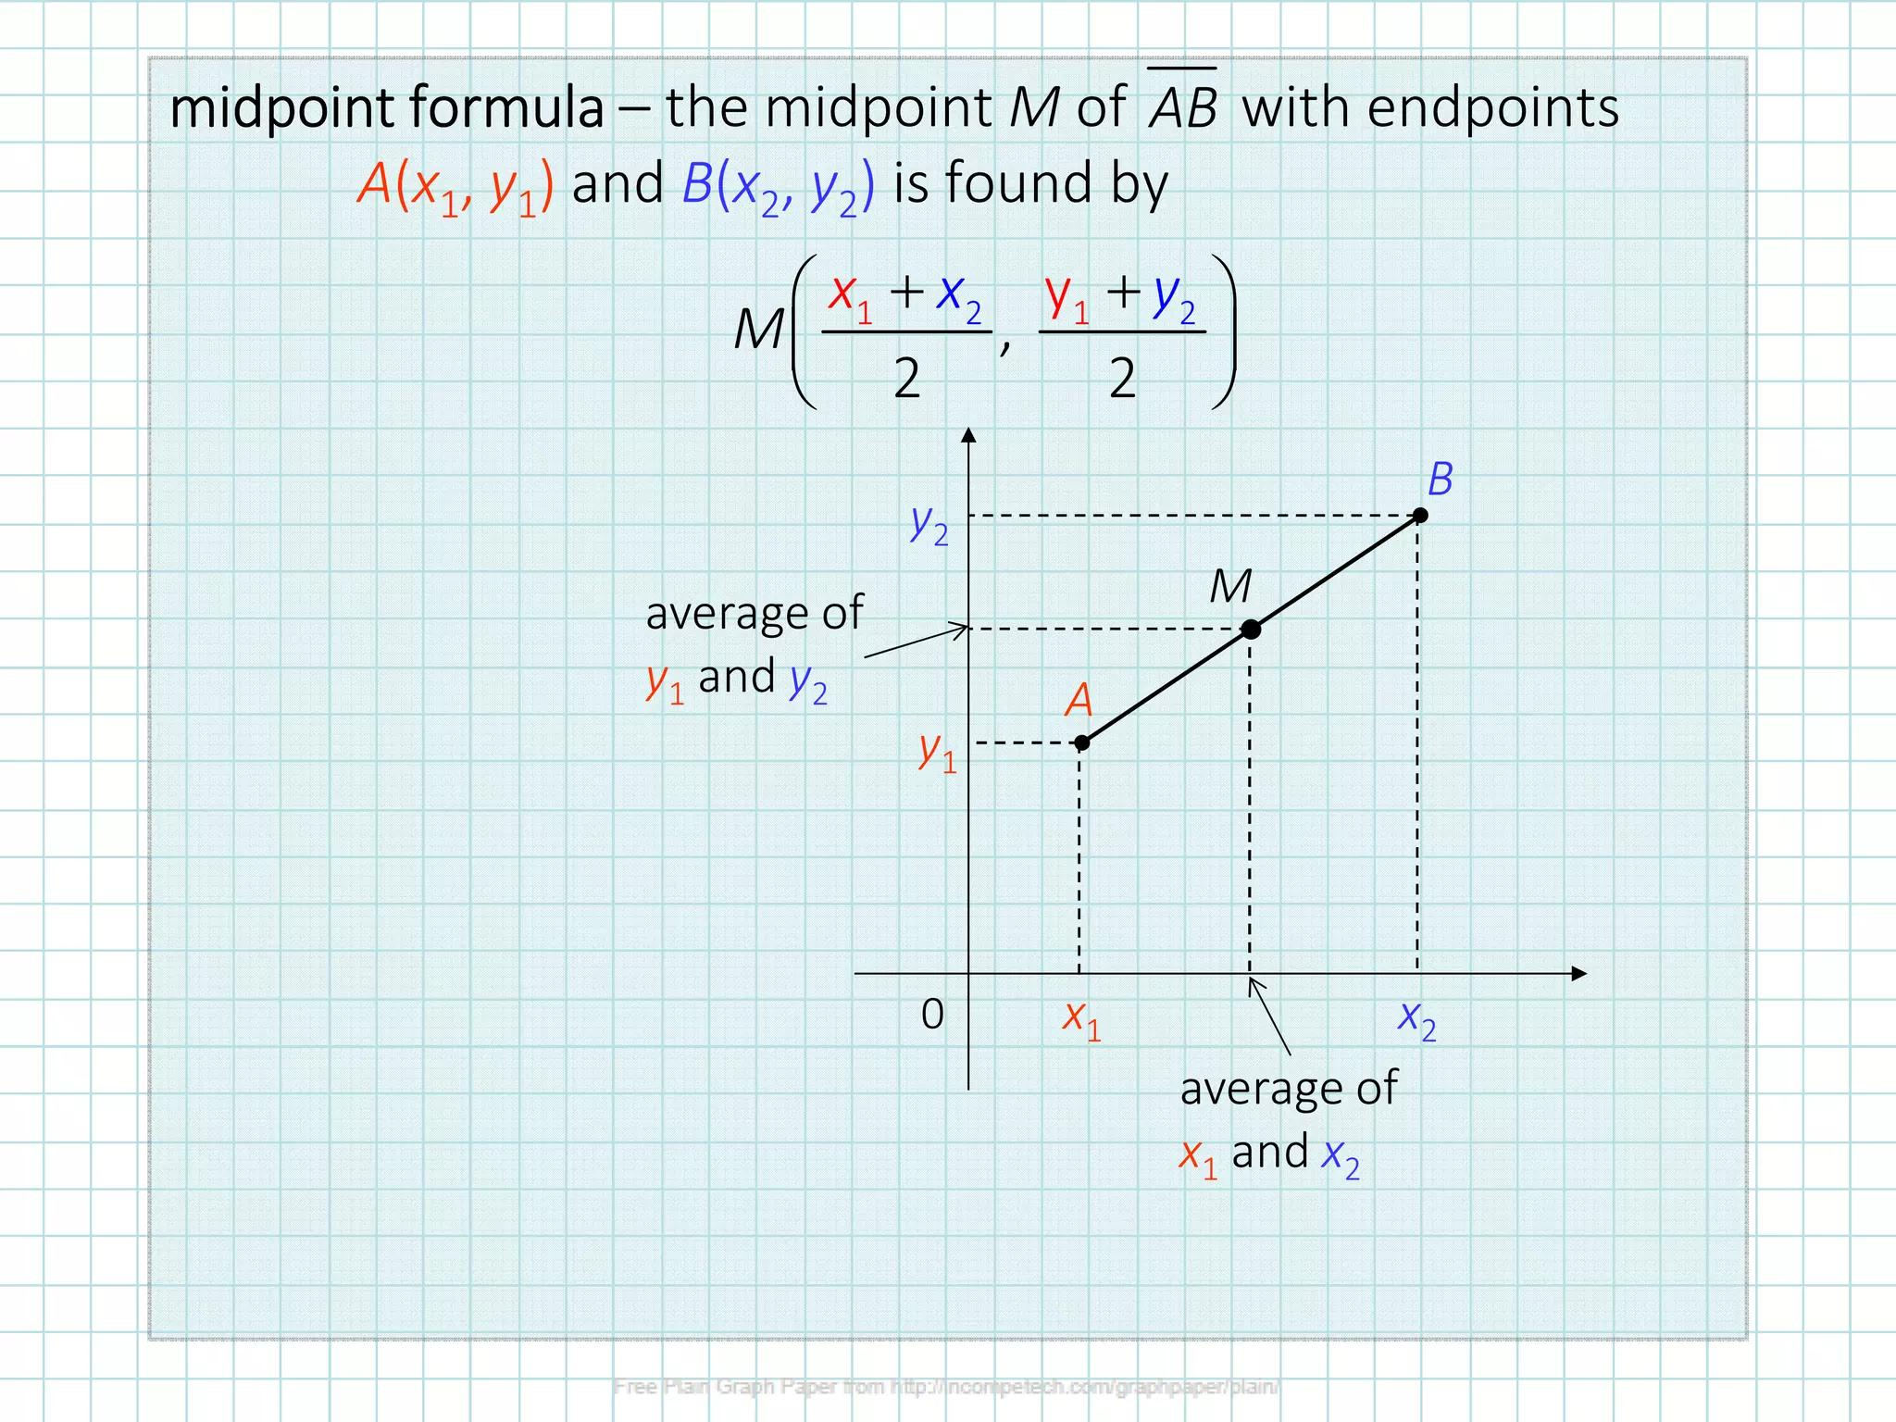
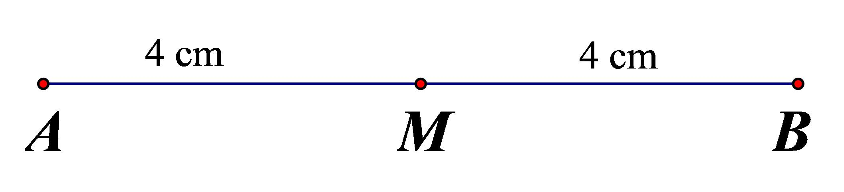
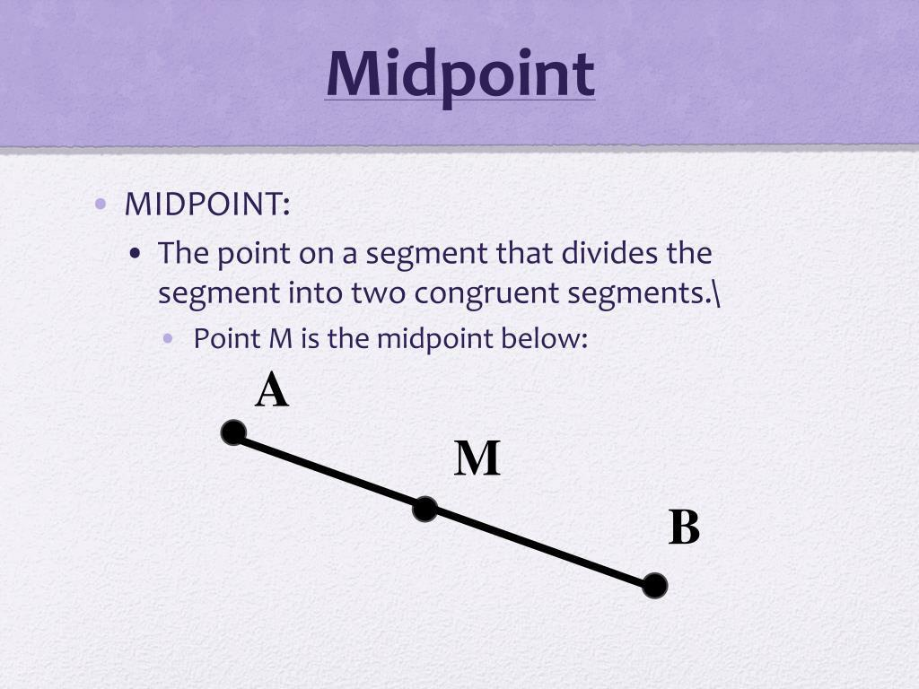

Purpose
# Source: AI Source: Provided by: [Data Path: Persons Table -> ID Column: 1, Name_En Column: Motasem Essam] -> From: [ChatGPT] on [7/25/2026]
The midpoint is used to:
- Divide a segment into two equal parts.
- Find the center of a line segment.
- Determine the center of a geometric figure or construction.
- Solve coordinate-geometry problems.
- Define and use the perpendicular bisector of a segment.
- Construct geometric figures accurately.

Basic Configuration
# Source: AI Source: Provided by: [Data Path: Persons Table -> ID Column: 1, Name_En Column: Motasem Essam] -> From: [ChatGPT] on [7/25/2026]
Consider the segment:
$$\overset{‾}{AB}$$
with $M$between $A$and $B$:
$$A∙ ⟶ M ⟶ ∙B$$
If $M$is the midpoint:
$$AM=MB$$
and therefore:
$$AB=AM+MB=2AM=2MB$$

Midpoint vs. Endpoint
# Source: AI Source: Provided by: [Data Path: Persons Table -> ID Column: 1, Name_En Column: Motasem Essam] -> From: [ChatGPT] on [7/25/2026]
These are different concepts.
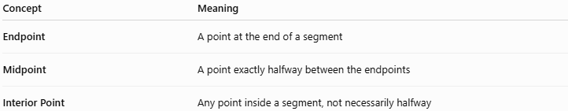
Concept | Meaning
Endpoint | A point at the end of a segment
Midpoint | A point exactly halfway between the endpoints
Interior Point | Any point inside a segment, not necessarily halfway
For:
$$A∙⟶M⟶∙B$$
$A$and $B$are endpoints, while $M$is the midpoint if:
$$AM=MB$$

Midpoint Formula
# Source: AI Source: Provided by: [Data Path: Persons Table -> ID Column: 1, Name_En Column: Motasem Essam] -> From: [ChatGPT] on [7/25/2026]
For two points in the coordinate plane:
$$A\left(x_{1} , y_{1}\right)$$
and
$$B\left(x_{2} , y_{2}\right)$$
the midpoint $M$ is:
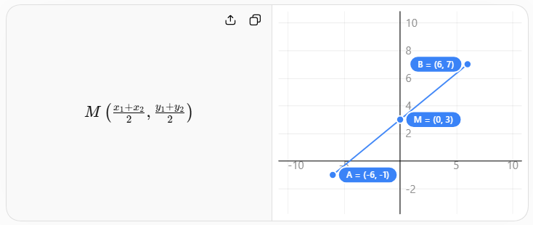
$$\boxed{M\left(\frac{x_{1}+x_{2}}{2} , \frac{y_{1}+y_{2}}{2}\right)}$$
The midpoint coordinates are obtained by averaging the corresponding coordinates.

Example 1: Numerical Segment
# Source: AI Source: Provided by: [Data Path: Persons Table -> ID Column: 1, Name_En Column: Motasem Essam] -> From: [ChatGPT] on [7/25/2026]
Suppose:
$$AB=14$$
and $M$is the midpoint.
Since:
$$AM=MB$$
we have:
$$AM=MB=\frac{14}{2}$$
Therefore:
$$\boxed{AM=MB=7}$$

Example 2: Coordinate Midpoint
# Source: AI Source: Provided by: [Data Path: Persons Table -> ID Column: 1, Name_En Column: Motasem Essam] -> From: [ChatGPT] on [7/25/2026]
Given:
$$A\left(2 , 4\right)$$
and:
$$B\left(8 , 10\right)$$
Using:
$$M=\left(\frac{x_{1}+x_{2}}{2} , \frac{y_{1}+y_{2}}{2}\right)$$
we get:
$$M=\left(\frac{2+8}{2} , \frac{4+10}{2}\right) \\ M=\left(5 , 7\right)$$
Therefore:
$$\boxed{M\left(5 , 7\right)}$$

Example 3: Finding a Missing Endpoint
# Source: AI Source: Provided by: [Data Path: Persons Table -> ID Column: 1, Name_En Column: Motasem Essam] -> From: [ChatGPT] on [7/25/2026]
Suppose $M\left(5 , 6\right)$is the midpoint of:
$$A\left(2 , 4\right)$$
and:
$$B\left(x , y\right)$$
Using the midpoint formula:
$$5=\frac{2+x}{2}$$
so:
$$10=2+x \\ x=8$$
For the $y$-coordinate:
$$6=\frac{4+y}{2} \\ 12=4+y \\ y=8$$
Therefore:
$$\boxed{B\left(8 , 8\right)}$$

Midpoint and Segment Addition
# Source: AI Source: Provided by: [Data Path: Persons Table -> ID Column: 1, Name_En Column: Motasem Essam] -> From: [ChatGPT] on [7/25/2026]
If $M$is the midpoint of $\overset{‾}{AB}$:
$$AM=MB$$
and:
$$AB=AM+MB$$
Therefore:
$$\boxed{AB=2AM=2MB}$$
For example, if:
$$AM=9$$
then:
$$MB=9$$
and:
$$AB=18$$

Midpoint and Perpendicular Bisector
# Source: AI Source: Provided by: [Data Path: Persons Table -> ID Column: 1, Name_En Column: Motasem Essam] -> From: [ChatGPT] on [7/25/2026]
The perpendicular bisector of a segment passes through its midpoint and is perpendicular to the segment.
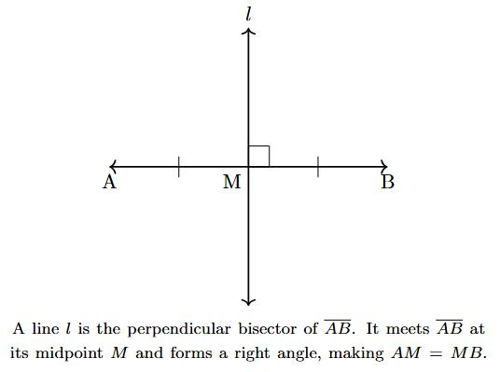
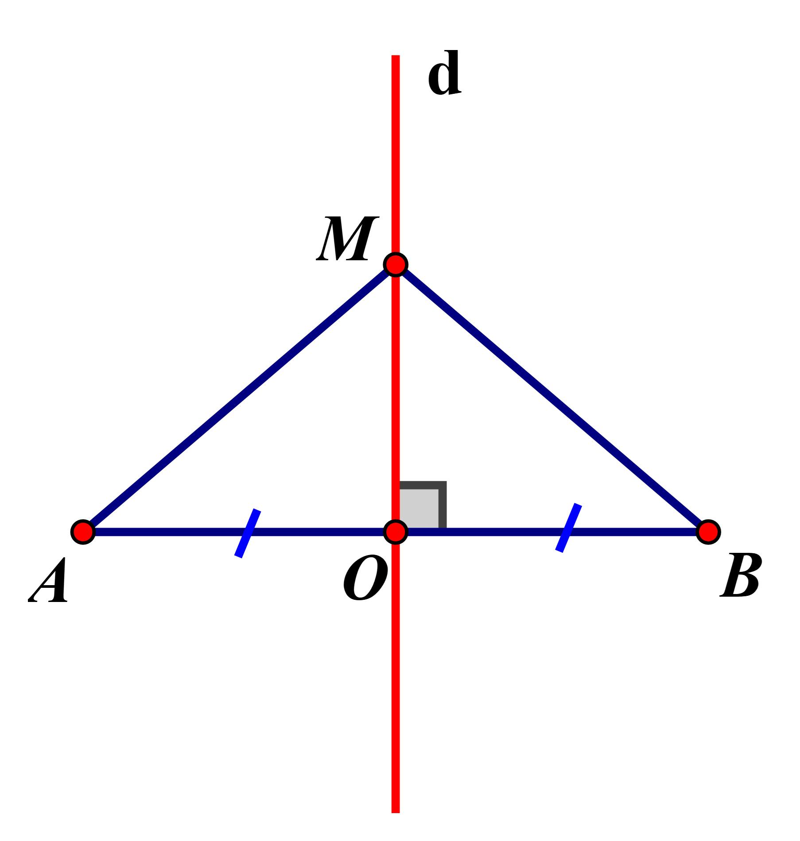
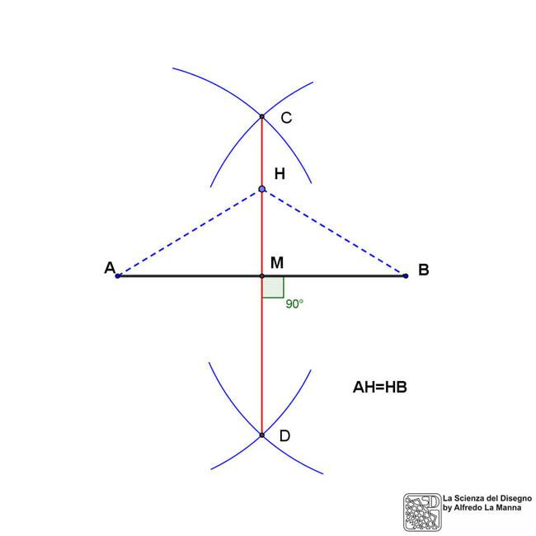
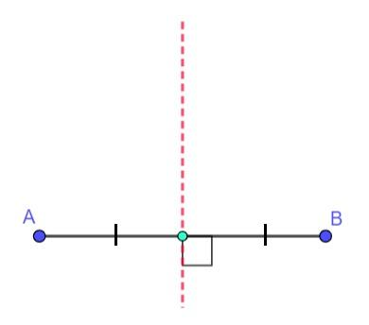
If $M$ is the midpoint of $\overset{‾}{AB}$, and line $l$passes through $M$ such that:
$$l⊥\overset{‾}{AB}$$
then $l$ is the perpendicular bisector of $\overset{‾}{AB}$.

Midpoint in a Triangle
# Source: AI Source: Provided by: [Data Path: Persons Table -> ID Column: 1, Name_En Column: Motasem Essam] -> From: [ChatGPT] on [7/25/2026]
A midpoint can also be used on the sides of a triangle.
If $D$is the midpoint of $\overset{‾}{AB}$, then:
$$AD=DB$$
If $E$is the midpoint of $\overset{‾}{AC}$, then:
$$AE=EC$$
Connecting two side midpoints produces a midsegment, which is parallel to the third side.
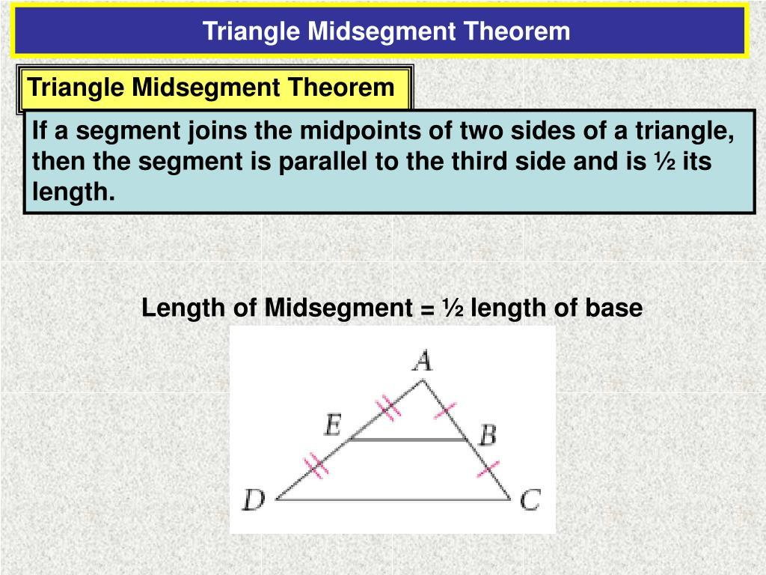
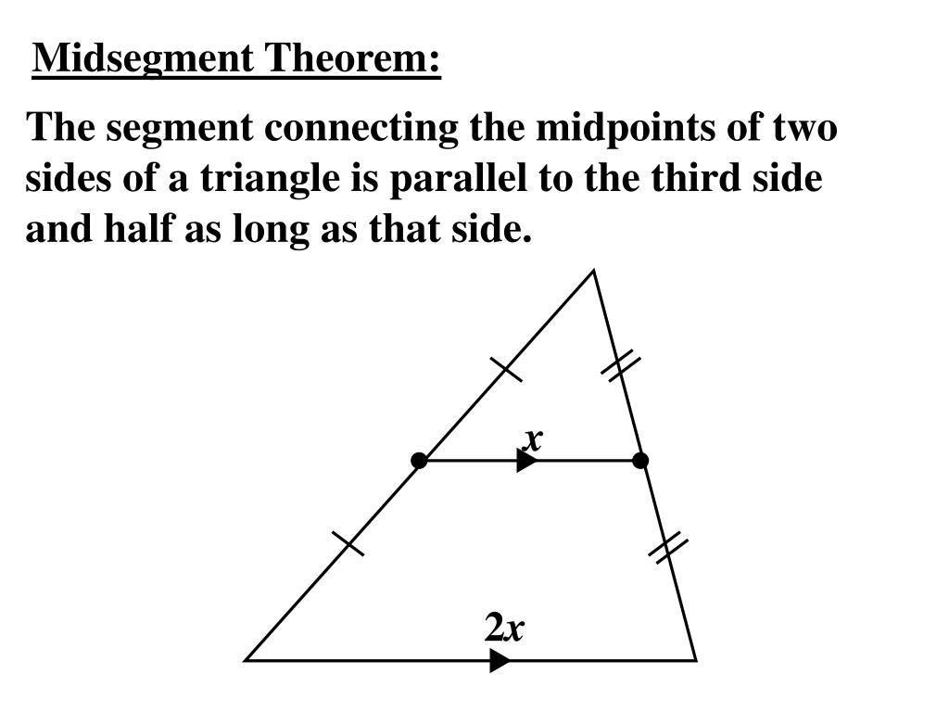
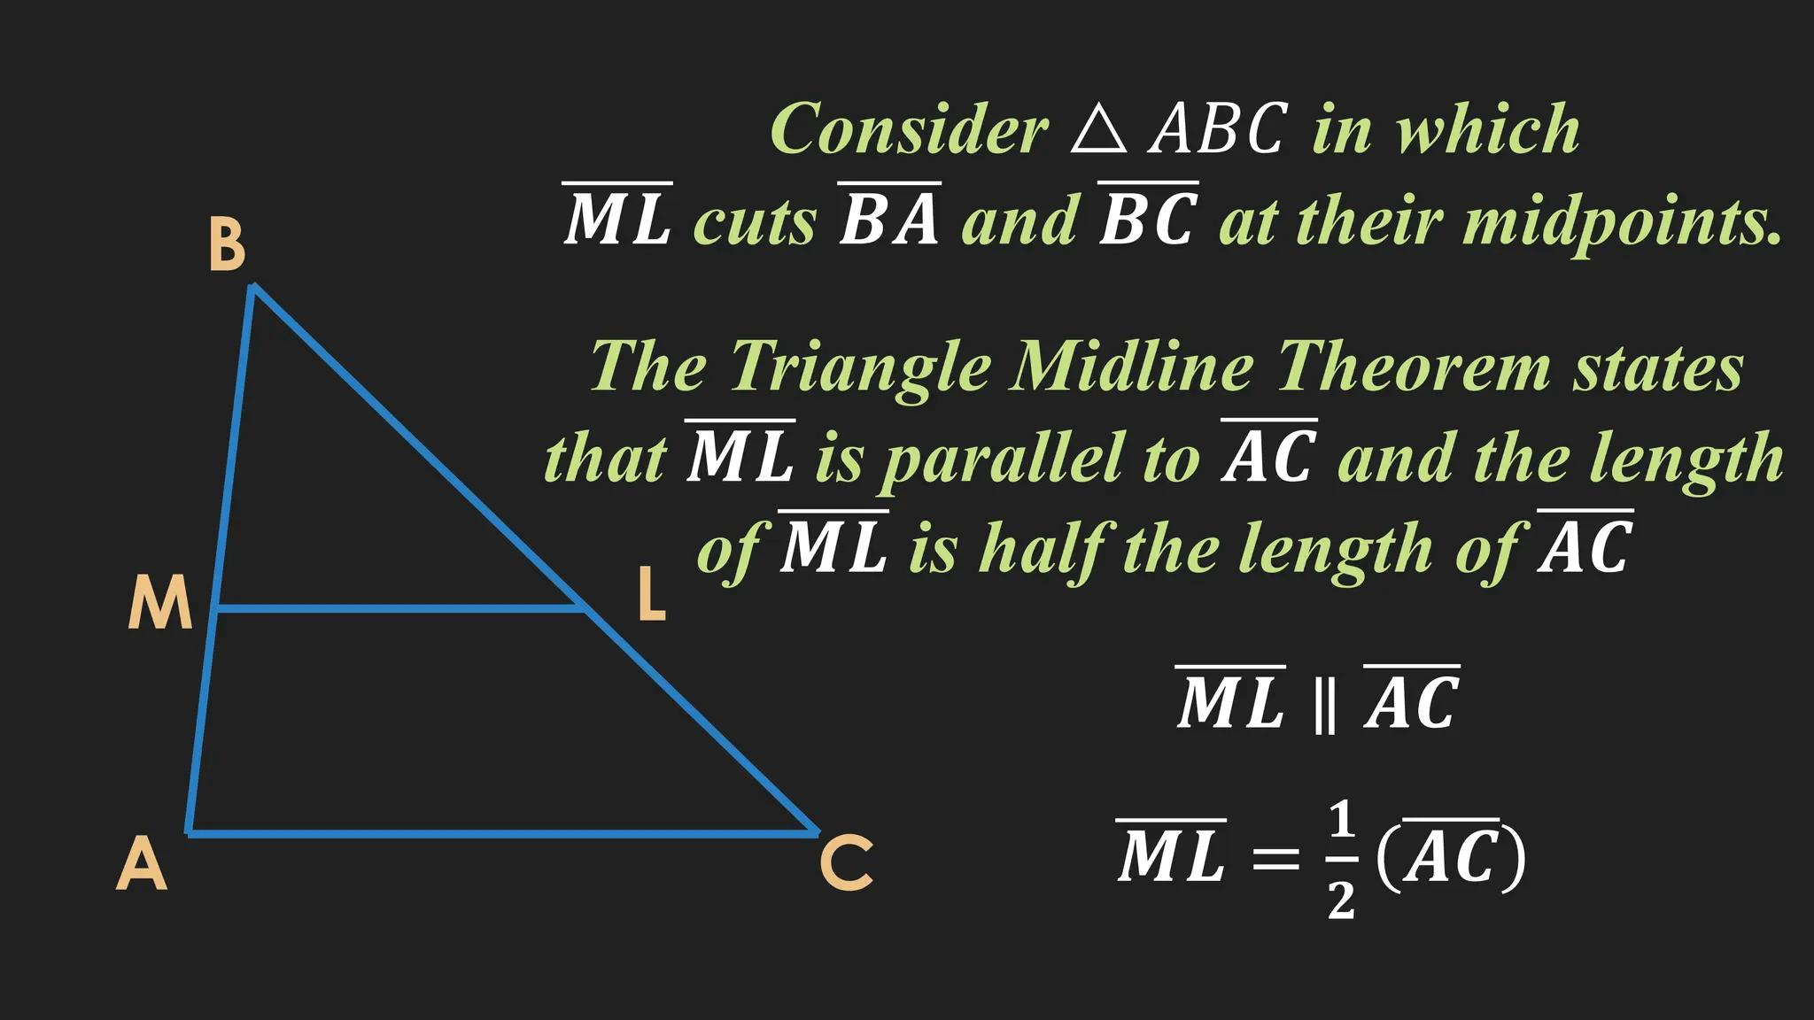
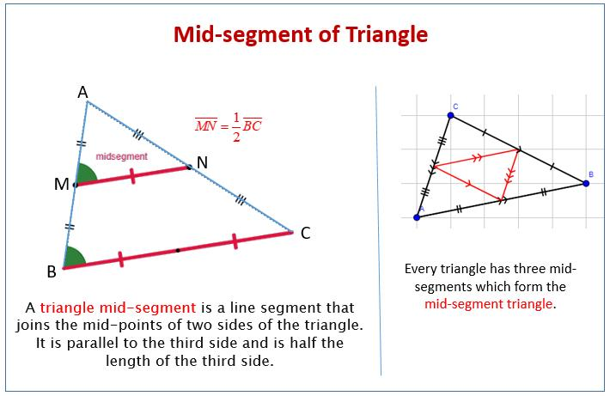
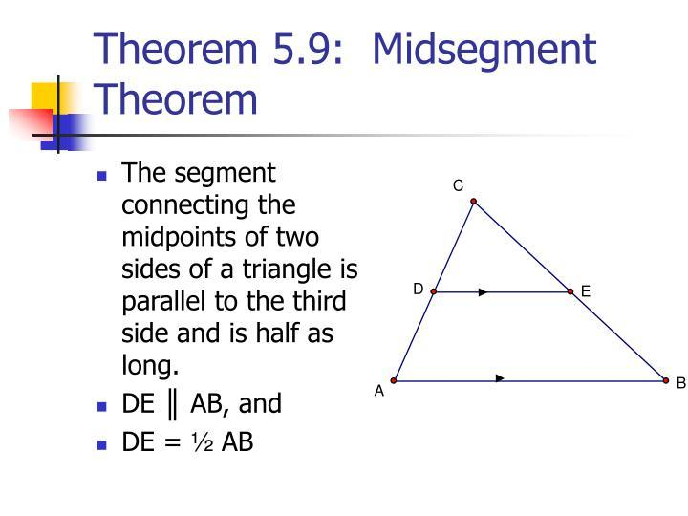

Important Properties
# Source: AI Source: Provided by: [Data Path: Persons Table -> ID Column: 1, Name_En Column: Motasem Essam] -> From: [ChatGPT] on [7/25/2026]
If $M$is the midpoint of $\overset{‾}{AB}$:
- $M$lies on $\overset{‾}{AB}$.
- $AM=MB$.
- $M$divides $AB$into two congruent segments.
- $M$is exactly halfway between $A$and $B$.
- $M$is unique for a given segment.
- The perpendicular bisector of $AB$passes through $M$.

Midpoint in Different Contexts
# Source: AI Source: Provided by: [Data Path: Persons Table -> ID Column: 1, Name_En Column: Motasem Essam] -> From: [ChatGPT] on [7/25/2026]
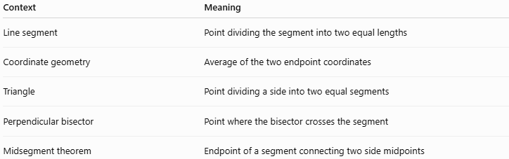
Context | Meaning
Line segment | Point dividing the segment into two equal lengths
Coordinate geometry | Average of the two endpoint coordinates
Triangle | Point dividing a side into two equal segments
Perpendicular bisector | Point where the bisector crosses the segment
Midsegment theorem | Endpoint of a segment connecting two side midpoints

Comparison with Related Concepts
# Source: AI Source: Provided by: [Data Path: Persons Table -> ID Column: 1, Name_En Column: Motasem Essam] -> From: [ChatGPT] on [7/25/2026]
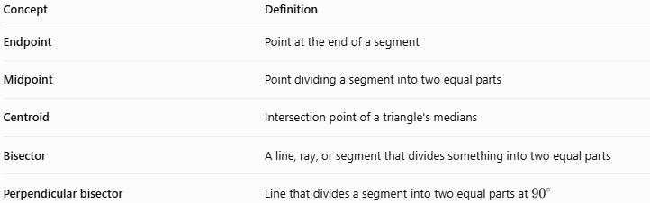
Concept | Definition
Endpoint | Point at the end of a segment
Midpoint | Point dividing a segment into two equal parts
Centroid | Intersection point of a triangle's medians
Bisector | A line, ray, or segment that divides something into two equal parts
Perpendicular bisector | Line that divides a segment into two equal parts at ${90}^{∘}$

Real-World Applications
# Source: AI Source: Provided by: [Data Path: Persons Table -> ID Column: 1, Name_En Column: Motasem Essam] -> From: [ChatGPT] on [7/25/2026]
Midpoints are useful for:
- Finding the center of a straight wall.
- Positioning an object exactly halfway between two points.
- Designing structures.
- Finding the center of a road segment.
- Dividing a piece of material into equal lengths.
- Computer graphics and geometric modeling.
- Mapping and surveying.

Key Points
# Source: AI Source: Provided by: [Data Path: Persons Table -> ID Column: 1, Name_En Column: Motasem Essam] -> From: [ChatGPT] on [7/25/2026]
- A midpoint divides a segment into two equal segments.
- If $M$is the midpoint of $\overset{‾}{AB}$:
$$\boxed{AM=MB}$$
- The midpoint formula is:
$$\boxed{M\left(\frac{x_{1}+x_{2}}{2} , \frac{y_{1}+y_{2}}{2}\right)}$$
- A midpoint is an interior point, not an endpoint.
- Every line segment has exactly one midpoint.
- The perpendicular bisector passes through the midpoint.
- Midpoints are fundamental in coordinate geometry, triangle geometry, and geometric constructions.

Conclusion
# Source: AI Source: Provided by: [Data Path: Persons Table -> ID Column: 1, Name_En Column: Motasem Essam] -> From: [ChatGPT] on [7/25/2026]
The midpoint is the unique point exactly halfway along a line segment. It divides the segment into two congruent parts and provides an important connection between segments, coordinates, perpendicular bisectors, medians, and midsegments.

